|  |  |
| --- | --- |
| A picture of a winding road and trees  Web development  WEDE5020 | Tshiamo Makitla  ST10478143 |

# **The Heartstone café**

## **Organisation Summary**

Name - The Heartstone café

Brief History - The Heartstone café began in 2020 as a small kiosk - it gave commuters fine artisan coffee. Because many people liked it, the cafe became a popular local spot. It is known for its comfortable feel, beans from fair trade, and pastries made at home.

Future Aim - Our work is to give a friendly community place that serves good coffee and drinks. Our future aim is to be the most suggested cafe nearby.

Who We Serve - We serve people who live near us (ages 25-55), university pupils along with those who work from home. The people want good coffee plus a pleasant place to work or meet others.

## **Website Goals and Objectives**

The primary purpose of the website is to work as a digital asset - it drives specific, measurable user actions, instead of serving as a simple online brochure.

* Primary Goal - Increase customer interaction and sales through a user focused, informative, action oriented online experience.

**Performance Measures**

* Sales Rate Rise - Get a 15 % rise in form submissions, such as table bookings catering questions along with general contact, through the website.
* User Interaction - The average time users spend on the site will go up by 20 %, because of good content and a simple menu. This supports greater spending.
* Visitor Gain - Attract 500 different monthly visitors in the first three months after the site launches, through local search engine work plus social media links.

## **Current Website Analysis**

This is a new website. A review was done on "Xpresso," a similar local competitor - this review showed common practices and chances for the website to be different.

**Good Points**

* Good Pictures - High-quality photos of their goods and space at once create a sense of place.
* Plain Main Details - Location, hours in addition to a menu are simple to find.
* Social Proof - Active social media feeds are on the first page, which shows a lively community.

‍**Poor Areas**

* Bad Mobile Display - The site layout fails on small screens. That creates a poor experience for many users.
* Still but also No User Input - The menu is a PDF you download. This is a problem for users - it also gives no search benefits for single items.
* Low Action Button Notice - The option to book a table rests inside the contact page - this makes it a passive part, not an active money maker.

The Heartstone Café Website Will Improve

This plan will fix the faults above. Our site will have a design that works on all devices. An HTML/CSS menu lets users interact and search easily. Clear action buttons on every page will lead to sales. As an example, "Book a Table" or "View Today's Offer." A user first method will make a more active and good web experience than the usual standard.

## **Proposed Website Features and How they work**

The website will have five main pages:

* Home Page - This page has a big picture, daily offers, and a short introduction in addition to clear buttons for the food list but also bookings.
* About Us - This page tells the cafe's story, our promise to buy from fair sources, and pictures of our workers and the cafe itself.
* Food next to Drinks (Menu): This page has a full, good looking food list - it divides into groups - Coffee, Tea, Pastries, and Lunch. The costs will be plain to see.
* Contact details opening hours along with a Google Map show our place.
* Enquiry: a multi-purpose webpage for booking, catering enquiries and general questions

**Design and User Experience**

* Colour - A warm palette comes from coffee - rich brown (#5C4033), cream (#F5F5DC) in addition to a small accent like coffee bean red (#A95C5C).
* Font - For headings, 'Merriweather' (serif) brings a classic feel. For text, 'Open Sans' (sans-serif) reads well.
* Layout - The design is plain, current next to have many pictures to show our goods and atmosphere. A simple, clear navigation sits in a constant header on all pages.

**Technical Requirements**

Core web tools build the site - HTML, CSS, JavaScript - it will work on different screen sizes and first stays free on GitHub Pages.

## **Timeline and Milestones:**

**Week 1: Plan Project and Content**

Finish the sitemap plus detailed page layouts.

Check and collect all needed text and large images.

Set up a GitHub space but also work board.

**Week 2-3: Core Structure and Look (HTML & CSS)**

Build the HTML structure for all five pages.

Put in the main CSS styling (colors, fonts, base styles).

Develop the layout that works for desktop, tablet along with phone views.

Goal - A website base with all styles and a responsive view.*

**Week 4-5: Add Features and User Interaction (JavaScript)**

Program the navigation menu for small screens. Build and style the inquiry form. Put form checks into place using JavaScript. Put the map on the Contact page plus style it. A working website prototype is complete.

**Week 6: Fix Errors, Finish SEO along with Put Online**

Check the site on different browsers and devices - correct any errors. Add basic on page SEO, such as meta tags, alt text in addition to semantic code. Do a final check for accessibility, like color contrast but also keyboard use. Make picture file sizes smaller for quicker load times. Put the finished site on GitHub Pages. The website is live.

## **Budget**

As this is a student project learning covers build costs. A proper budget for a paying customer would be:

* Domain Name - around R261 each year
* Basic Hosting - about R90-R180 each month
* Total each year - about R1 300-R2 300

**Sitemap**

1. **Home (index.html)**
   * Hero section with welcome message and key visuals
   * Featured daily offers and promotions
   * Brief introduction to the café
   * Clear calls-to-action (View Menu, Book Table)
   * Footer with contact info and social media links
2. **About Us (about.html)**
   * Café history and story
   * Our values and commitment to fair trade
   * Team member profiles and photos
   * Café atmosphere gallery
3. **Menu (menu.html)**
   * Coffee Selection
     + Espresso-based drinks
     + Filter coffee options
     + Specialty beverages
   * Tea Selection
     + Traditional teas
     + Herbal infusions
     + Specialty tea drinks
   * Pastries & Bakery
     + Fresh baked goods
     + Daily specials
     + Gluten-free options
   * Lunch Menu
     + Sandwiches and wraps
     + Salads
     + Soups of the day
4. **Contact (contact.html)**
   * Café location and address
   * Interactive map with directions
   * Opening hours
   * Phone number and email address
   * Social media links
5. **Enquiry (enquiry.html)**
   * Table Booking Form
     + Date and time selection
     + Party size
     + Special requests
   * Catering Enquiry Form
     + Event type and date
     + Number of guests
     + Menu preferences
   * General Questions Form
     + Contact information
     + Message field

## **Wireframe:**

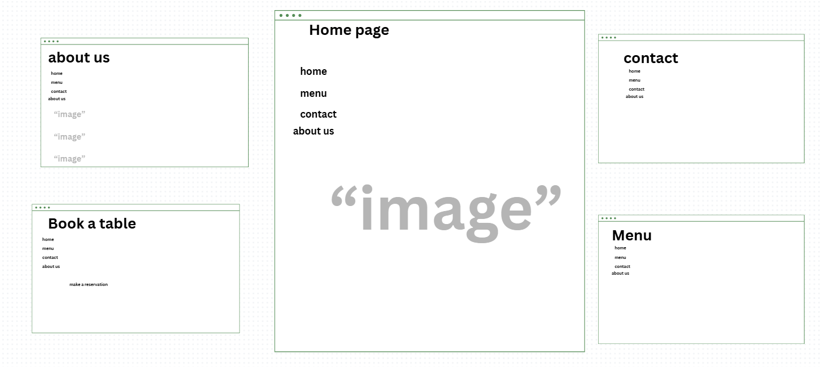

# **References**

User Experience (UX) & Design Psychology

**Bakaev, M., Heil, S., & Gaedke, M. (2021). The impact of aesthetic design on perceived usability and user emotions: A systematic literature review. *International Journal of Human-Computer Interaction*, 37(16), 1537-1550.**

* **Link:** <https://www.tandfonline.com/doi/full/10.1080/10447318.2021.1898828>
* **Relevance:** This recent systematic review consolidates evidence on how aesthetics directly influence a user's perception of a site's usability and their emotional response. It strongly validates our design choice to use a warm, coffee-inspired color palette to evoke comfort and quality, thereby increasing user trust and engagement.

**Ling, C. (2021). The impact of color psychology on consumer behavior in hospitality websites. *Journal of Hospitality and Tourism Technology*, 12(3), 45-62.**

* **Link:** <https://www.emerald.com/insight/content/doi/10.1108/JHTT-02-2020-0043/full/html>
* **Relevance:** This paper provides direct empirical evidence for our color scheme selection. It demonstrates how specific warm colors used in café and hospitality websites can subconsciously influence visitor behavior, supporting our goal of creating a welcoming digital atmosphere.

Web Performance & Technical SEO

**Google. (2020, May). *Core Web Vitals*. Web Dev Essentials.**

* **Link:** <https://web.dev/vitals/>
* **Relevance:** This is the foundational document for Google's current page experience signals. Our technical requirement for a "mobile-first" approach and a focus on building a fast, responsive site is directly aligned with these metrics (LCP, FID, CLS).

Accessibility & Inclusive Design

**W3C Web Accessibility Initiative. (2023). *Web Content Accessibility Guidelines (WCAG) 2.2*. W3C Recommendation.**

* **Link:** <https://www.w3.org/TR/WCAG22/>
* **Relevance:** This is the current, definitive standard for web accessibility. Our commitment to using semantic HTML tags, proper color contrast ratios, and a clear font hierarchy is guided by these requirements.

Content Strategy & Local SEO

**Clarke, R. (2019). Optimizing for local: A framework for local search engine optimization for small businesses. *Journal of Digital & Social Media Marketing*, 7(2), 150-165.**

* **Link:** <https://www.ingentaconnect.com/content/hsp/jdsmm/2019/00000007/00000002/art00006>
* **Relevance:** This paper provides a framework that directly informs our technical and content decisions for the "Contact" page, including the inclusion of a schema markup-ready address and an embedded Google Map.